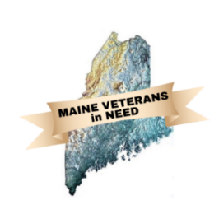Maine Veterans in Need

November 19, 2024

Meeting place is

**Mid-Coast Veterans Council**

at 1:00 PM

Meeting ZOOM

<https://us02web.zoom.us/j/88137580485?pwd=STNmZzdaeVB2cW5DNjU1SmlVR1RWdz09>

Meeting ID: 881 3758 0485

Passcode: 777765

DRAFT

Turn on “recording”

Attendance Introductions:

MVN Officers

David Patch

James Bachelder

Mike Roy

MVN Members

Elks

Lewin

MCVC

Pine Tree Legal

V.E.T.S.

Wellness Mobile

Approval of Agenda

Monthly reports:

Secretary’s Report: Minutes from the October meetings

Treasurer’s Report: The Treasurers report,

Available Funds

* MVN – Lodging Account, Operating Account, Total.
* Elks -
* VFW: Hotel Stays $– Stand-Down Funds $

New Attendee Introductions:

Unfinished Business:

1. Case Worker Training Review
2. By Name List status: Intro to Karen Martin
3. MVN October Client Summary
4. Fundraisers Scheduled

New Business:

1. A review of our Mission
2. VEFAP: Status (FEDCAP/Veterans)
3. Social Media: Review and input
   1. Facebook: Nancy Hamlen Manager
   2. Website: Dan McWalters Manager

Updates:

1. Update from participants.

Additional agenda items.

Adjourn

Next meeting on Tuesday, 17 December at 1:00 PM

New Zoom Invite

Time: December, 2024 01:00 PM Eastern Time (US and Canada)

<https://us02web.zoom.us/j/88137580485?pwd=STNmZzdaeVB2cW5DNjU1SmlVR1RWdz09>

Meeting ID: 881 3758 0485

Passcode: 777765