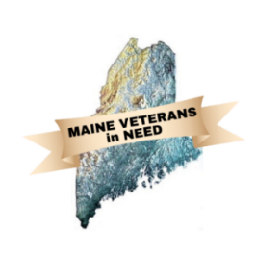Maine Veterans in Need

June 18, 2024

Meeting place is

**Mid-Coast Veterans Council**

at 1:00 PM

Meeting ZOOM

<https://us02web.zoom.us/j/88137580485?pwd=STNmZzdaeVB2cW5DNjU1SmlVR1RWdz09>

Meeting ID: 881 3758 0485

Passcode: 777765

DRAFT

Turn on “recording”

Attendance Introductions:

MVN Officers

David Patch

James Bachelder

Mike Roy

MVN Members

Elks

Lewin

MCVC

Pine Tree Legal

V.E.T.S.

Wellness Mobile

Guests

Paws for Vets: Roy Driver

Approval of Agenda

Monthly reports:

Secretary’s Report: Minutes from the April meetings

Treasurer’s Report: The Treasurers report,

Available Funds

MVN – Lodging Account, Operating Account, Total.

Elks -

VFW: Hotel Stays $– Stand-Down Funds $

Paws for Vets Presentation: Roy driver

Unfinished Business:

1. Stand-Downs preparation update (Matt, Jim and Brian)
2. By Name List status
3. MVN May Client Summary
4. Fundraisers Scheduled
   1. Rotary Boothbay Harbor: 20 June
   2. TD Bank: 18 July
   3. Brunswick Rotary: 19 August
5. Furniture Committee meeting update/Elks Augusta Trailer procedures

New Business:

1. New Member Vote: Androscoggin Bank
2. Secretary Officer Vote: Angela Greenwald
3. Case Worker Training

Updates:

1. Update from participants.

Additional agenda items.

Adjourn

Next meeting on Tuesday, 20 August at 1:00 PM

New Zoom Invite

David Patch is inviting you to a scheduled Zoom meeting.

Topic: MVN Monthly Meeting

Time: Mar 19, 2024 01:00 PM Eastern Time (US and Canada)

<https://us02web.zoom.us/j/88137580485?pwd=STNmZzdaeVB2cW5DNjU1SmlVR1RWdz09>

Meeting ID: 881 3758 0485

Passcode: 777765