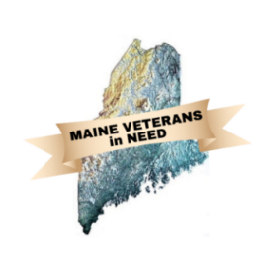Maine Veterans in Need

May 21, 2024

Meeting place is

**Mid-Coast Veterans Council**

at 1:00 PM

Meeting ZOOM

<https://us02web.zoom.us/j/88137580485?pwd=STNmZzdaeVB2cW5DNjU1SmlVR1RWdz09>

Meeting ID: 881 3758 0485

Passcode: 777765

DRAFT

Turn on “recording”

Attendance Introductions:

MVN Officers

David Patch

James Bachelder

Mike Roy

MVN Members

Elks

Lewin

MCVC

Pine Tree Legal

V.E.T.S.

Wellness Mobile

Guests

Brian Cummings

MBVS

Jarad Golden

Ken Gotreau

Approval of Agenda

Monthly reports:

Secretary’s Report: Minutes from the April meetings

Treasurer’s Report: The Treasurers report,

Available Funds

MVN – Lodging Account, Operating Account, Total.

Elks -

VFW: Hotel Stays $– Stand-Down Funds $

Preble St Presentation: Michael Roy (tentative)

Unfinished Business:

1. Stand-Downs preparation update (Matt, Jim and Brian)
2. By Name List status
3. MVN April Client Summary
4. Fundraisers Scheduled
   1. Bath Rotary: 4 June
   2. Rotary Boothbay Harbor: 20 June
   3. Congregational Church BBH: 26 May
   4. Brunswick Rotary: 19 August
5. Furniture Committee meeting update/Elks Augusta Trailer procedures
6. Secretary position update

New Business:

1. VEFAP update (Brian)
2. April Veteran tracking

Updates:

1. Update from participants.

Additional agenda items.

Adjourn

Next meeting on Tuesday, 20 August at 1:00 PM

New Zoom Invite

David Patch is inviting you to a scheduled Zoom meeting.

Topic: MVN Monthly Meeting

Time: Mar 19, 2024 01:00 PM Eastern Time (US and Canada)

<https://us02web.zoom.us/j/88137580485?pwd=STNmZzdaeVB2cW5DNjU1SmlVR1RWdz09>

Meeting ID: 881 3758 0485

Passcode: 777765